Trade Review Deep Agent
A Multi-Agent, Human-in-the-Loop System for Futures Trade Review and Compliance
Project Details Document
Use Case Definition | Implementation | Benefits | Value Add

Table of Contents

1. Use Case Definition 3
1.1 Problem Statement 3
1.2 One-Line Definition 3
1.3 Scope and Boundaries 3
1.4 Success Criterion 3
2. Solution Architecture 4
2.1 Key Design Principle 4
3. Implementation 4
3.1 Grounding 4
3.2 Specialist Subagents 5
3.3 Tools 6
3.4 Persistence and Memory 6
3.5 End-to-End Workflow 6
3.6 Human-in-the-Loop Decision Point 7
4. Benefits 7
4.1 Speed 7
4.2 Consistency 8
4.3 Auditability 8
4.4 Safety by Construction 8
4.5 Reduced Rule-Miss Risk 8
5. Value Add to the Financial Portfolio Trade Review and Compliance Process 8
5.1 For the Trader 8
5.2 For Risk and Compliance 8
5.3 For Process Governance 8
5.4 For Institutional Memory 9
5.5 Net Effect 9
6. Agent Framework Specification (Week 3 Format) 9
7. Disclaimer 10

1. Use Case Definition

1.1 Problem Statement
Every proposed futures trade on the portfolio currently requires a trader to manually cross-check three things before acting: the technical and macro backdrop for the contract, the correct position size under the portfolio's risk caps, and compliance with a fixed set of hard risk rules. Done by hand, this cross-checking takes roughly 15–20 minutes per idea, is repetitive, and is exactly the kind of task where a tired or rushed reviewer can miss a rule violation — oversized risk, an excluded sector overlap, a missing stop, or a reward:risk ratio below the portfolio's floor.

1.2 One-Line Definition
The Trade Review Deep Agent helps a futures trader decide whether to take a proposed trade on a $100,000 portfolio, replacing the manual cross-check of technical bias, risk sizing, and compliance rules with an automated research-size-check-critique pipeline. It researches the contract's current setup, sizes the position under the 1–2% risk cap, checks it against hard portfolio risk rules, drafts a trade ticket, and hands off to the trader for a final, explicit approve/reject decision before anything is ever marked “taken.”

1.3 Scope and Boundaries
- In scope: futures-trade review for a 10-contract universe across four sectors (equities, metals, energy, bonds) on a single $100,000 account.
- Out of scope: real order placement. execute_trade is a simulated tool only — no order is ever sent to a broker.
- Out of scope: investment advice to third parties. This is an internal decision-support tool for one portfolio's own trader, not a recommendation engine for other investors.

1.4 Success Criterion
A trader can get a go/no-go decision, with full reasoning, in under two minutes — a decision they would act on roughly eight times out of ten.

2. Solution Architecture
The system is built on the Deep Agents framework (LangChain's agent layer over LangGraph): one orchestrator plans the review and delegates to four specialist subagents, each with isolated context and a narrow toolset. A shared filesystem carries the trade ticket between agents; a Store provides memory that survives across sessions; and a single human-approval gate sits in front of the only action capable of taking the trade.
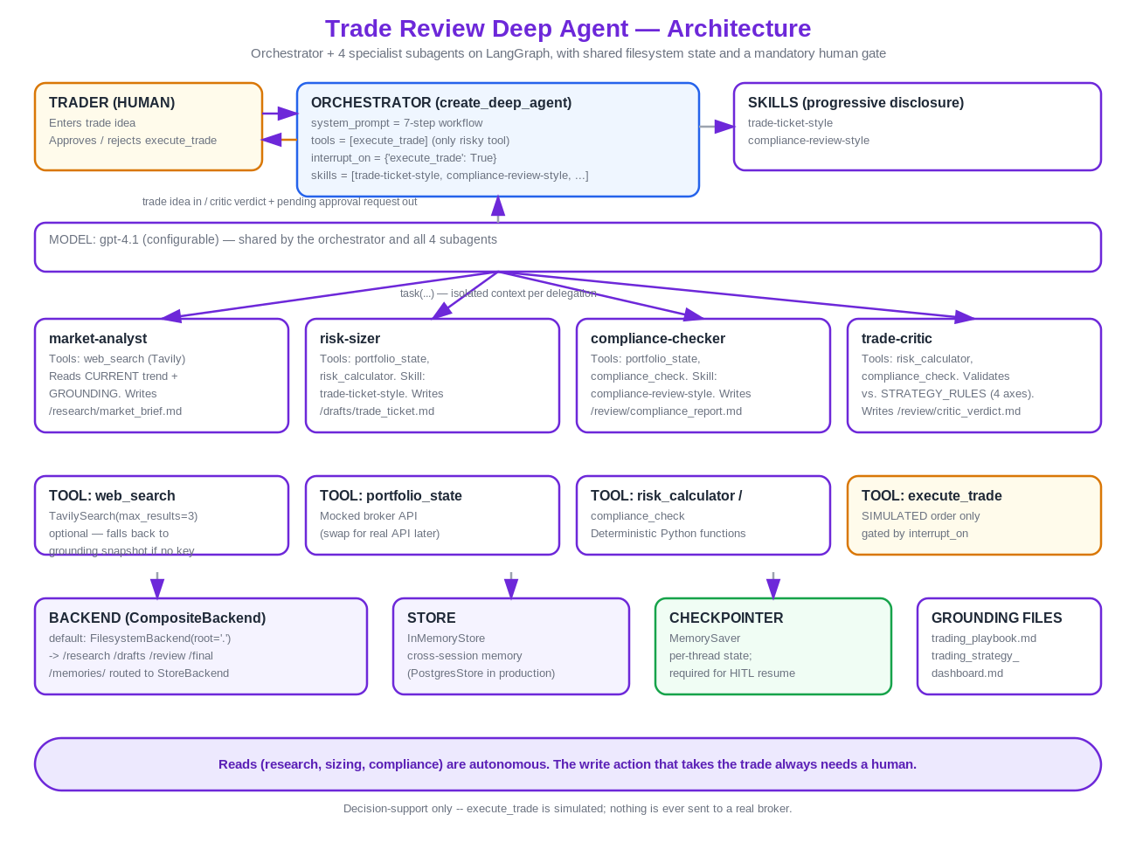
Figure 1. System architecture — orchestrator, four subagents, shared backends, and the human gate.

2.1 Key Design Principle
Reads are autonomous; the one write action is not. Researching the market, sizing the position, and checking compliance all happen without a human in the loop — but execute_trade, the only action that marks a trade “taken,” is gated behind mandatory human approval on every single run. This boundary is enforced structurally (interrupt_on={'execute_trade': True}), not just by instruction.

3. Implementation

3.1 Grounding
The agent is grounded in two files it must never invent beyond:
- trading_playbook.md — the hard “never” rules (2% single-trade cap, 6% portfolio heat cap, same-sector limits, mandatory stop, mandatory human approval) plus a dated macro snapshot used only as a labeled fallback when live search is unavailable.
- trading_strategy_dashboard.md — the detailed entry/exit/sizing rulebook and a live per-contract performance scorecard (grades A through D) that the critic validates every trade against.

3.2 Specialist Subagents
Subagent | Tools | Writes
market-analyst | web_search (optional, live) | /research/market_brief.md
risk-sizer | portfolio_state, risk_calculator | /drafts/trade_ticket.md
compliance-checker | portfolio_state, compliance_check | /review/compliance_report.md
trade-critic | risk_calculator, compliance_check | /review/critic_verdict.md

The trade-critic is the final cross-check: it validates consistency between the ticket and the compliance report, confirms every claim is grounded in the research brief or playbook (including catching any date-mislabeling between a live search and the stale snapshot), checks completeness of the ticket, and validates the trade against the strategy dashboard's entry rules, sizing bands, and live contract grade. A contract graded D is flagged explicitly even if the ticket otherwise passes every hard rule — the human makes the final call on D-graded contracts.
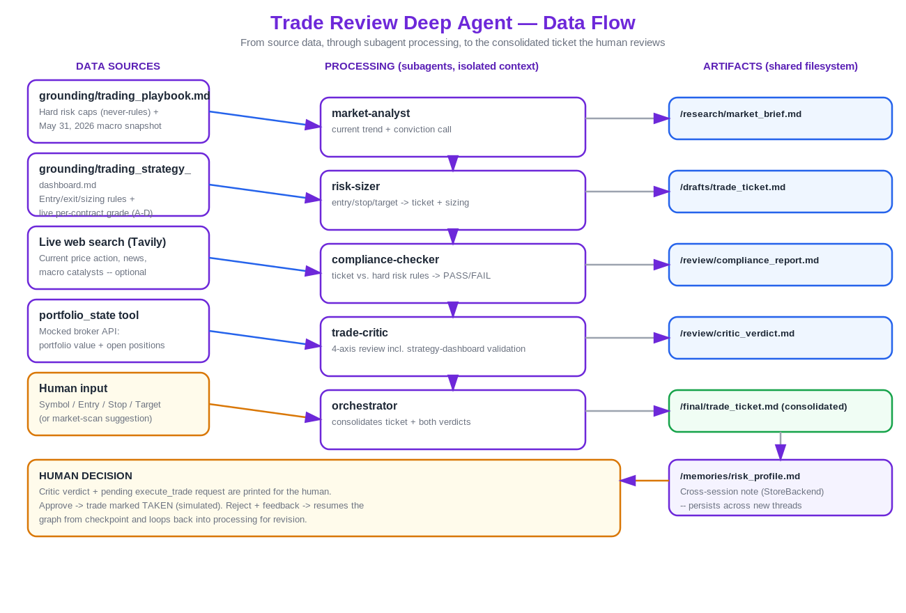
Figure 2. Data flow — sources, subagent processing, and the shared-filesystem artifacts each stage produces.

3.3 Tools
- web_search (Tavily) — optional live technical/macro context; falls back to the grounding snapshot with an explicit disclosure if unavailable.
- portfolio_state — deterministic lookup of current portfolio value and open positions (mocked; swappable for a real broker/portfolio API).
- risk_calculator — deterministic dollar-risk, position-size, and reward:risk arithmetic. The model drafts the idea; plain code does the math.
- compliance_check — deterministic PASS/FAIL against the hard risk rules.
- execute_trade — a simulated “take the trade” action, gated behind human approval. Nothing is ever sent to a real broker.

3.4 Persistence and Memory
A CompositeBackend routes by path: everything under /research, /drafts, /review, and /final lands on disk via a FilesystemBackend, so the artifacts are visible in a normal file explorer during review. Everything under /memories/ routes to a StoreBackend instead, which survives across sessions — a new conversation thread can still recall the risk profile and any flags raised on a prior trade. A checkpointer (MemorySaver) holds per-thread state and is required for the human-in-the-loop interrupt to pause and resume correctly.

3.5 End-to-End Workflow
Each run starts with a market scan across the watchlist (ES, NQ, GC, CL, NG): a throwaway-thread call per contract proposes a candidate setup or reports none qualifies, before the trader commits to a specific idea. The trader's chosen setup then enters the full pipeline.
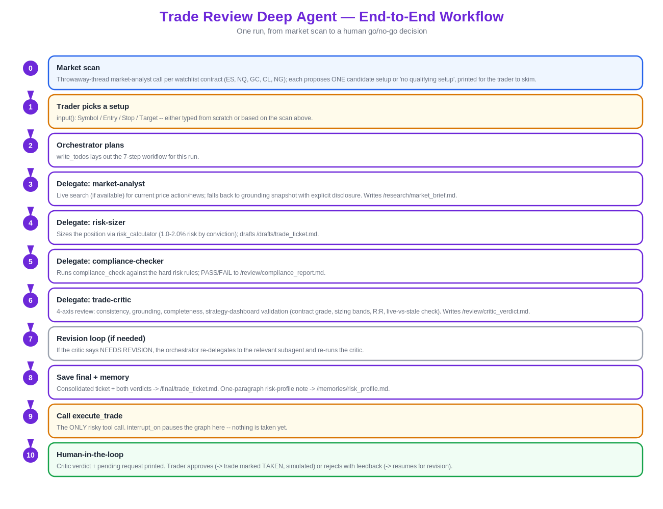
Figure 3. End-to-end workflow — from market scan to the human go/no-go decision.

3.6 Human-in-the-Loop Decision Point
Before the trader is asked to approve or reject, the system prints the trade-critic's full verdict — all four review axes, the READY FOR HUMAN REVIEW or NEEDS REVISION line, and any D/C-grade flag — so the decision is grounded in the critic's actual reasoning, not just the raw pending tool-call arguments. The trader can approve (the trade is marked TAKEN, still simulated), or reject with a written reason, which resumes the graph and sends the ticket back for revision rather than restarting the run from scratch.

4. Benefits

4.1 Speed
Replaces a 15–20 minute manual cross-check (technical read, sizing math, rule lookup) with an automated pipeline that completes in well under two minutes, including a multi-contract market scan the trader never had time to run by hand.

4.2 Consistency
Position sizing and compliance arithmetic are computed by deterministic code (risk_calculator, compliance_check), not estimated by a language model — the same inputs always produce the same risk amount, reward:risk ratio, and pass/fail verdict.

4.3 Auditability
Every stage of the review writes a file: the research brief, the draft ticket, the compliance report, the critic's verdict, and the consolidated final ticket. The full reasoning trail behind any decision is on disk, not buried in a chat transcript.

4.4 Safety by Construction
The only action capable of affecting a real position is structurally gated behind human approval on every run — not as a style of prompting, but as a graph-level interrupt that requires an explicit resume. execute_trade itself never contacts a real broker; it is a simulation.

4.5 Reduced Rule-Miss Risk
The critic's four-axis review and the strategy dashboard's live per-contract grading catch the kinds of misses a rushed manual review is prone to: an under-target reward:risk ratio, a stale or mislabeled market read, a contract that has been underperforming (C/D grade), or a sector-concentration breach.

5. Value Add to the Financial Portfolio Trade Review and Compliance Process

5.1 For the Trader
A single consolidated file (/final/trade_ticket.md) replaces several manual lookups: current technical/macro read, exact position size and dollar risk, compliance pass/fail with citations, and an independent critic's verdict — all before the trader is asked to make one yes/no call.

5.2 For Risk and Compliance
Hard risk rules (2% single-trade cap, 6% portfolio heat cap, same-sector limits, mandatory stop, minimum reward:risk) are enforced the same way on every single trade idea, with a written PASS/FAIL citation trail — removing the variability of a manual reviewer's judgment call under time pressure, and creating a durable record for any later review of how a given trade was approved.

5.3 For Process Governance
The strategy dashboard's live performance scorecard is wired directly into the review: a contract graded D is never silently approved, and a C-graded contract is flagged to confirm size was reduced as the dashboard requires. This turns a static quarterly review document into an input the system actively checks against on every trade, not just when someone remembers to look it up.

5.4 For Institutional Memory
The /memories/risk_profile.md note persists across sessions, so flags raised on one trade (a tight reward:risk, a D-graded contract, a stale data read) are not lost when the conversation ends — they are available to the very next review of the same portfolio.

5.5 Net Effect
The agent does not replace the trader's judgment — it removes the repetitive, error-prone cross-checking that precedes that judgment, and it does so without ever weakening the one control that matters most: a human always makes the final call before a trade is taken.

6. Agent Framework Specification (Week 3 Format)
The table below answers the Week 3 Agentic AI Systems framework's forcing questions for this agent, based directly on trade_deep_agent.ipynb, so every layer of the design reflects an explicit decision rather than something left implicit.
Field | Fill in (1 to 2 sentences max)
Agent goal (one line) | Decide whether a proposed futures trade on a $100,000 portfolio is ready to take — research the setup, size it, check it against hard risk rules, and critique it — then hand off to a human for the final go/no-go.
Where do people use it? | Inside the Jupyter notebook itself (trade_deep_agent.ipynb): the trader runs the notebook's cells and answers live input() prompts in the notebook output to enter a trade setup and to approve or reject the final recommendation.
What steps does it take, in order? | 1. Market-scan the watchlist for candidate setups. 2. Trader enters/picks a setup. 3. Orchestrator plans (write_todos) and delegates to market-analyst, risk-sizer, compliance-checker, and trade-critic in sequence (re-looping on NEEDS REVISION). 4. Orchestrator saves the final ticket, verdict, and a memory note, then calls execute_trade, which pauses for human approval.
What can it actually do? | web_search and portfolio_state only look things up (read); risk_calculator and compliance_check only compute/check (read, no side effect); write_todos and the file writes to /research, /drafts, /review, /final, and /memories create persistent records (write); execute_trade is the one action that changes something — it marks the trade TAKEN, simulated only, and is gated behind human approval.
What does it need to remember? | Within a run, just the current thread's trade idea and scan results; across sessions, /memories/risk_profile.md — a one-paragraph note on each reviewed trade's risk profile and any flags (D-grade contract, weak R:R, stale data) — so the next session's review isn't starting from zero.
What should it never do? | Never call execute_trade without an explicit human approval; never invent risk rules, strategy rules, or market facts beyond the grounding files and research; never let a single trade exceed the 2% risk cap or push portfolio heat over 6%; never place a real order — execute_trade is simulation only.

Field | Fill in (1 to 2 sentences max)
Human-in-the-loop | After the trade-critic marks the ticket READY FOR HUMAN REVIEW and the orchestrator calls execute_trade, the graph interrupts and pauses; the human sees the critic's full verdict plus the pending trade request, then approves, or rejects with a written reason that resumes the run and sends the ticket back for revision.
What happens when something breaks? | If compliance_check returns FAIL and one revision pass can't fix it, the orchestrator stops and reports the failure instead of calling execute_trade; if a market-scan call or the main run hits the recursion_limit, a GraphRecursionError is caught and reported (e.g. “SCAN INCOMPLETE”) rather than the agent looping indefinitely.
How do you know it worked? | The trader gets a go/no-go decision, with full reasoning (critic verdict, compliance citations, sizing math) in under two minutes — the notebook's own success criterion is that this is a decision the trader would act on about eight times out of ten.

7. Disclaimer
This system and document are for educational and informational purposes only. They do not constitute financial advice. execute_trade is a simulated tool only — no real order is ever placed with a broker. Futures trading involves substantial risk of loss.

